**HOW TO BE A PROXY FOR DP-STAGING**

1. INSTALL AND RUN CCPROXY



1. Click on Options > E

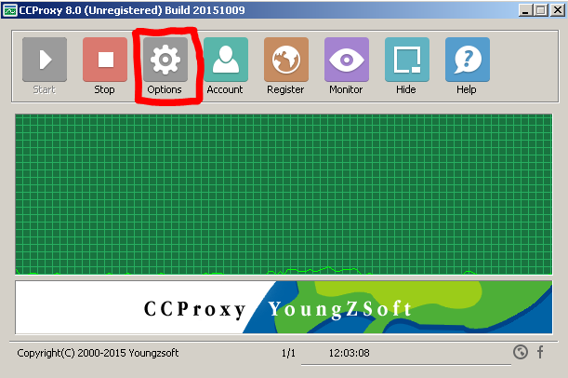

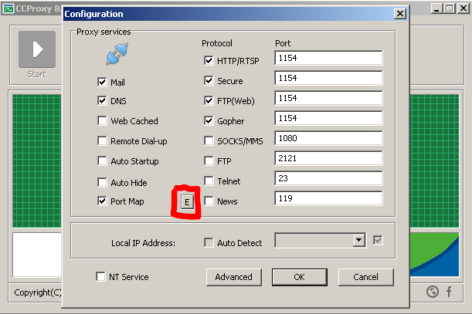

1. Add **stg.apis.smart.com.ph** and its staging IP counter-part

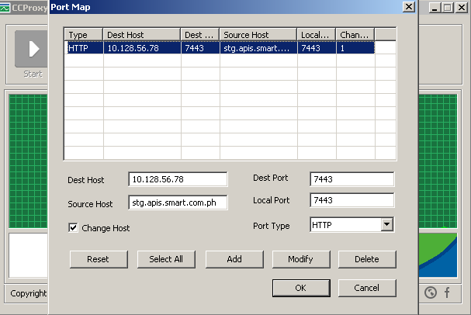

1. Enter IP of PC host (where CCProxy is running) and port 1154

